

A PROJECT REPORT

on

CUSTOMER LOYALTY SYSTEM FOR AN CUISINE

Submitted in partial fulfillment of requirements for the award of the course of

### ECA1121–PYTHON PROGRAMMING

Under the guidance of

#### Ms .M. INDHU B.E.,

**Assistant Professor/CSE**

*SubmittedBy*

**SARVESH (8115U23EC095)**

**DEPARTMENTOFCOMPUTERSCIENCEAND ENGINEERING**

# K.RAMAKRISHNANCOLLEGEOFENGINEERING

(AnAutonomousInstitution,affiliatedtoAnnaUniversityChennaiandApprovedbyAICTE, New Delhi)

**SAMAYAPURAM–621112**

MAY2024

 

# K.RAMAKRISHNANCOLLEGEOFENGINEERING

(AnAutonomousInstitution,affiliatedtoAnnaUniversityChennaiandApprovedbyAICTE, New Delhi)

**SAMAYAPURAM–621112**

MAY2024

## BONAFIDE CERTIFICATE

## 

Certified that this project report titled**“CUSTOMER LOYALTY TOWARDS AN CUISINE”**is the bonafide work of **SARVESH (8115U23EC095),** who carried out the project work under my supervision. Certified further, that to the best of my knowledge the work reported in does not form part of any other project reportor dissertation on the basis of which a degree or award was conferred on an earlier occasion on this or any other candidate.

|  |  |
| --- | --- |
| **SIGNATURE**  Dr.M.MAHESHWARI Ph.D.,  **HEAD OF THE DEPARTMENT**  ASSOCIATE PROFESSOR,  DepartmentofComputer Science and Engineering,  K.RamakrishnanCollegeofEngineering(Autonomous)  Samayapuram–621112 | **SIGNATURE**  **Ms.M.INDHU B.E.,**  **SUPERVISOR**  ASSISTANTPROFESSOR,  Department of Computer Science and Engineering,,  K.RamakrishnanCollegeof Engineering  (Autonomous)  Samayapuram–621112 |

SubmittedfortheEnd Semester Examinationheldon…………….

**INTERNALEXAMINER EXTERNALEXAMINER**

# DECLARATION

I jointly declare that the project report on “CUSTOMER LOYALTY TOWARDS AN CUISINE” is the result of original work done by us and best of our knowledge, similar work has not been submitted to “ANNA UNIVERSITY CHENNAI” for the requirement of Degree of BACHELOR OF ENGINEERING. This project report is submitted on the partial fulfillment of the requirement of the award of degree of BACHELOR OF ENGINEERING.

|  |
| --- |
| **Signature** |
| SARVESH P |

Place: Samayapuram

Date:

# ACKNOWLEDGEMENT

It is with great pride that we express our gratitude and indebtedness to our institution, “**K. Ramakrishnan College of Engineering (Autonomous)**”, for providing us with the opportunity to do this project.

Weextendoursincereacknowledgmentandappreciationtotheesteemedand honorable Chairman, **Dr. K. RAMAKRISHNAN**, **B.E.,** for having provided the facilities during the course of our study in college.

We would like to express our sincere thanks to our beloved Executive Director, **Dr. S. KUPPUSAMY, MBA, Ph.D.,** for forwarding our project and offering an adequate duration to complete it.

Wewouldliketothank**Dr. D. SRINIVASAN, B.E, M.E.,Ph.D.,**

Principal,whogavetheopportunitytoframetheprojecttofullsatisfaction.

We thank **Dr.M.MAHESHWARI,Ph.D.,** Head ofthe Department of **COMPUTER SCIENCE AND ENGINEERING**, for providing her encouragement in pursuing this project.

We wish to convey our profound and heartfelt gratitude to our esteemed project guide **Ms.M.INDHU B.E.,** Departmentof **ELECTRONICS AND COMMUNICATION ENGINEERING,** for her incalculable suggestions, creativity,assistanceand patience, which motivated us to carry out this project.

We render our sincere thanks to the Course Coordinator and other staff members for providing valuable information during the course.

We wish to express our special thanks to the officials and Lab Technicians of our departments who rendered their help during the period of the work progress.

 

**VISION**

To achieve a prominent position among the top technical institutions

**MISSION**

* To bestow standard technical education par excellence through state of the art infrastructure, competent faculty and high ethical standards.
* To nurture research and entrepreneurial skills among students in cutting edge technologies.
* To provide education for developing high-quality professionals totransform the society.

**DEPARTMENT VISION AND MISSION**

**VISION**

To create eminent professionals of Computer Science and Engineering by imparting quality education.

**MISSION**

* To provide technical exposure in the field of Computer Science and Engineering through state of the art infrastructure and ethical standards.
* To engage the students in research and development activities in the field of Computer Science and Engineering.
* To empower the learners to involve in industrial and multi-disciplinary projects for addressing the societal needs.

**PROGRAMME EDUCATIONAL OBJECTIVES (PEOs)**

PEO1: Analyse, design and create innovative products for addressing social needs.

PEO2: Equip themselves for employability, higher studies and research.

PEO3: Nurture the leadership qualities and entrepreneurial skills for their successful career.

**PROGRAMOUTCOMES(POs)**

Engineeringstudentswillbeableto:

1. **Engineering knowledge:** Apply the knowledge of mathematics, science, engineering fundamentals,andanengineeringspecializationtothesolutionofcomplexengineeringproblems.
2. **Problem analysis:** Identify, formulate, review research literature, and analyze complex engineering problems reaching substantiated conclusions using first principles of mathematics, natural sciences, and engineering sciences.
3. **Design/development of solutions:** Design solutions for complex engineering problems and design system components or processes that meet the specified needs with appropriate consideration for the public health and safety, and the cultural, societal, and environmental considerations.
4. **Conduct investigations of complex problems:** Use research-based knowledge and research methodsincludingdesignofexperiments,analysisandinterpretationofdata,andsynthesisofthe information to provide valid conclusions.
5. **Modern tool usage:** Create, select, and apply appropriate techniques, resources, and modern engineeringandITtoolsincludingpredictionandmodelingtocomplexengineeringactivitieswith an understanding of the limitations.
6. **The engineer and society:** Apply reasoning informed by the contextual knowledge to assess societal,health,safety,legalandculturalissuesandtheconsequentresponsibilitiesrelevanttothe professional engineering practice.
7. **Environment and sustainability:** Understand the impact of the professional engineering solutionsinsocietalandenvironmentalcontexts,anddemonstratetheknowledgeof,andneedfor sustainable development.
8. **Ethics:**Applyethicalprinciplesandcommittoprofessionalethicsandresponsibilitiesandnorms of the engineering practice.
9. **Individualand team work:** Function effectively as an individual, and as amember or leader in diverse teams, and in multidisciplinary settings.
10. **Communication:** Communicate effectively on complex engineering activities with the engineering community and with society at large, such as, being able to comprehend and write effective reports and design documentation, make effective presentations, and give and receive clear instructions.
11. **Project management and finance:** Demonstrate knowledge and understanding of the engineering and management principles and apply these to one’s own work, as a member and leader in a team, to manage projects and in multidisciplinary environments.
12. **Life-long learning:** Recognize the need for, and have the preparation and ability to engage in independent and life-long learning in the broadest context of technological change.

**PROGRAMSPECIFICOUTCOMES(PSOs)**

**PSO1:** Apply the basic and advanced knowledge in developing software, hardware and firmware solutions addressing real life problems.

**PSO2:** Design, develop, test and implement product-based solutions for their career enhancement.

### ABSTRACT

In the highly competitive food industry, customer loyalty is a crucial determinant of long-term success. This abstract explores strategies to enhance customer loyalty towards a specific cuisine. It highlights the importance of understanding customer preferences, creating unique and memorable experiences, and leveraging digital tools for personalized engagement. Customer loyalty in the culinary sector extends beyond repeat visits; it encompasses an emotional connection to the cuisine. Establishing this bond is essential for sustained patronage and positive word-of-mouth referrals.

Customer loyalty in the culinary sector extends beyond repeat visits; it encompasses an emotional connection to the cuisine. Establishing this bond is essential for sustained patronage and positive word-of-mouth referrals.

The first step in fostering loyalty is understanding the diverse preferences of the customer base. This involves analyzing demographic data, conducting surveys, and gathering feedback to tailor offerings that meet and exceed customer expectations. Emphasizing local ingredients and traditional cooking methods can resonate with customersseeking authenticitThe dining experience significantly influences customer loyalty. This includes the quality of food, ambiance, service, and overall customer experience. Restaurants can enhance loyalty by offering exceptional customer service, engaging storytelling about the cuisine's origins, and creating a unique ambiance that reflects the culture associated with the cuisine

**TABLEOFCONTENTS**

|  |  |  |
| --- | --- | --- |
| **CHAPTERNO** | **TITLE** | **PAGENO** |
| **1** | **INTRODUCTION**   * 1. Introduction   2. Objectives   3. Project Summarization |  |
| **\*2** | **PROJECT METHODOLOGY**   * 1. Introduction to System Architecture   2. Detailed System Architecture Diagram |  |
| **3** | **PYTHONPREFERENCE**   * 1. Explanationofwhyadoublelinkedlistwaschosen   2. Comparison with other Data structures   3. Advantages and disadvantages of using a doubly linked list |  |
| **4** | **DATASTRUCTURESUSED**   * 1. String   2. List   3. Dictionary |  |
|  |  | |
| **5** | **MODULES**   * 1. Createanew contact   2. Displaythesavedcontact   3. Searchthecontact   4. DeleteContact   5. EditContact |  |
| **6** | **ERROR MANAGEMENT**  6.1 Input Validation  6.2 Exception handling |  |
| **7** | **RESULT & DISCUSSION**  7.1 Result  7.2 Discussion |  |
| **8** | **CONCLUSION & FUTURE SCOPE**  8.1 Conclusion  8.2 Future Scope |  |
|  | | |
| **REFERENCES**  **APPENDIX – A** | |

## CHAPTER1- INTRODUCTION

#### Introduction

#### In today's dynamic and competitive culinary landscape, customer loyalty is pivotal for the success and sustainability of restaurants and eateries. Establishing a loyal customer base not only ensures repeat business but also drives organic growth through positive word-of-mouth and brand advocacy. A well-designed customer loyalty program tailored to a specific cuisine can significantly enhance customer retention and engagement, transforming casual diners into ardent ambassadors of the cuisine.

#### Purpose and Importance

Increase Customer Retention:

1. Reward Loyal Customers: Provide incentives such as discounts,

free meals, or exclusive offers to customers who frequently dine

at your restaurant.

1. Build Emotional Connection:Foster a sense of belonging and

appreciation among customers, making them feel valued and

special.

1. Boost Revenue:

Encourage Repeat Visits: Loyal customers are more likely to visit

frequently and spend more per visit.

1. Increase Average Spend: Loyalty programs can be structured to encourage customers to try new dishes or spend above a certain amount to receive rewards.

#### Objectives

1. Increase Customer Retention

2. Boost Revenue

3. Enhance Customer Engagement

4.Increase customer Satisfaction

5.IncreaseBrandAdvocacy

#### 1.3ProjectSummarization

This project aims to develop and implement a comprehensive customer loyalty program focused on a specific cuisine. The goal is to increase customer retention, boost revenue, and enhance customer engagement by offering tailored rewards and personalized dining experiences. By leveraging data-driven insights, the program will cater to the preferences and habits of loyal customers, fostering a strong emotional connection with the brand.

Objectives

Increase Customer Retention:

* Achieve a 20% increase in repeat visits within the first year.

Boost Revenue:

* Increase average customer spend by 15% within six months.

Enhance Customer Engagement:

* Improve participation in loyalty program activities and events by 30%.

Gather Valuable Customer Insights:

* Collect detailed data on customer preferences and dining habits.

Improve Customer Satisfaction:

* Achieve a 90% satisfaction rate among loyalty program members.

Increase Brand Advocacy:

* Encourage 50% of members to refer new customers.

Drive Online and Offline Engagement:

* Increasedigitalengagement by 25%.

# CHAPTER 2

# PROJECTMETHODOLOGY

#### Introduction to Customer loyalty cuisine

#### In the competitive landscape of the culinary industry, customer loyalty has become a vital element for the sustained success of restaurants and food businesses. Customer loyalty refers to the ongoing preference of customers for a particular restaurant or cuisine, demonstrated through repeat patronage and advocacy. Building and maintaining customer loyalty is particularly crucial in the culinary world, where tastes, preferences, and dining experiences play a significant role in customer satisfaction and retention.

#### High-Level customer loyalty cuisine

#### High-level customer loyalty in cuisine involves creating a deeply engaged, repeat customer base that not only frequently returns to a restaurant but also becomes a passionate advocate for the brand. Achieving this level of loyalty requires a comprehensive approach that integrates exceptional service, personalized experiences, and meaningful connections. Here are the key elements that define high-level customer loyalty in the culinary world:

#### Exceptional Dining Experience

#### Personalized Experience

#### Components of the customer loyalty cuisine

#### 1. Quality and Consistency

#### Exceptional Food Quality: Delivering consistently high-quality dishes that meet or exceed customer expectations.

#### Consistent Service: Providing excellent and reliable service every time a customer dines.

#### 2. Personalized Customer Experience

#### Customer Recognition: Acknowledging regular customers and personalizing their experience based on their preferences and dining history.

#### Tailored Offers: Offering personalized promotions, discounts, and menu recommendations.

#### 3. Loyalty Rewards Program

#### Point-Based System: Customers earn points for every purchase, which can be redeemed for rewards such as discounts, free items, or exclusive experiences.

#### Tiered Membership Levels: Different levels of membership (e.g., Silver, Gold, Platinum) that offer escalating benefits and incentives for increased loyalty.

#### Detailed customer loyalty system

.

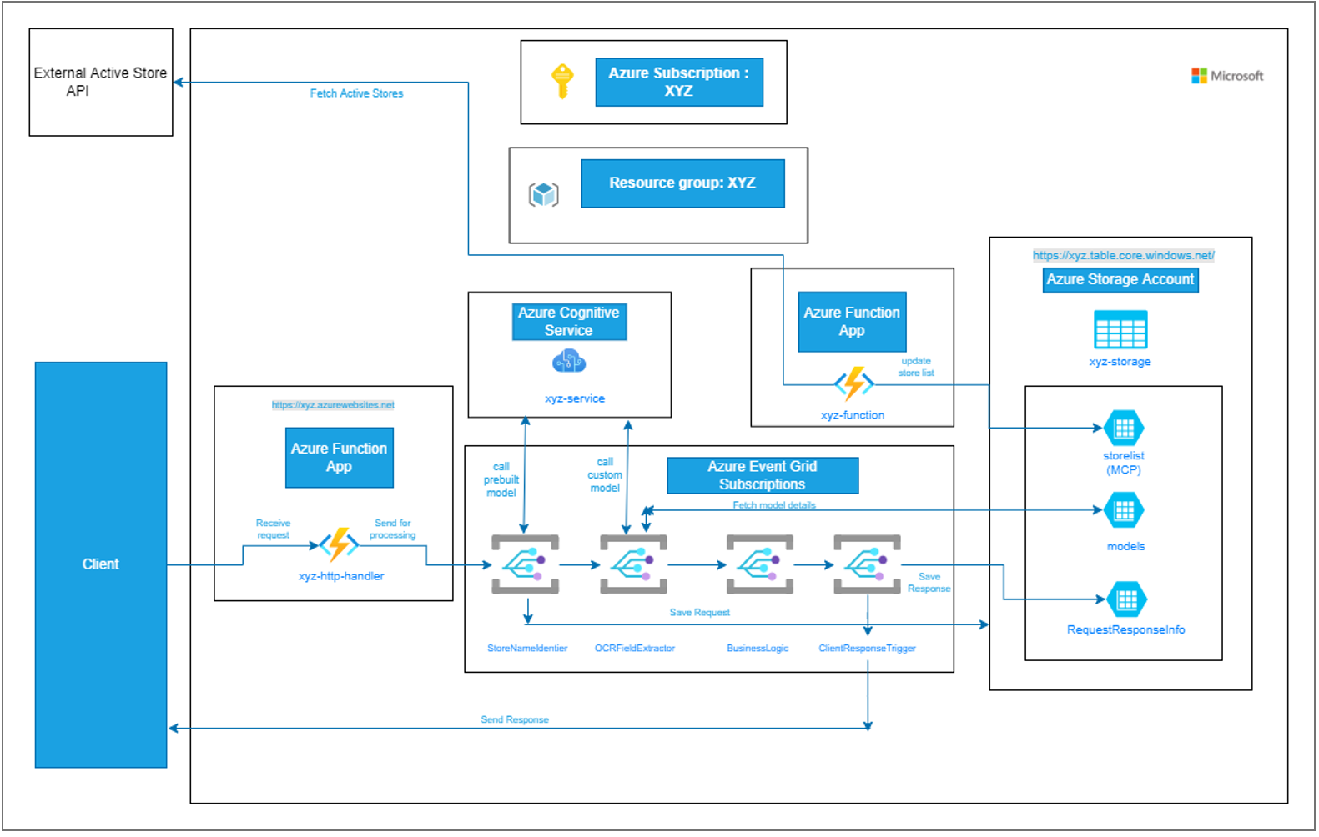

# CHAPTER3

**PYTHON PREFERENCE**

#### Explanation of why a constructer was chosen

#### In object-oriented programming (OOP), constructors play a crucial role.A constructor is a special method within a class that gets called when an object of that class is created. Its primary purpose is to initialize the object’s properties (variables) and set their initial values

#### Features in Python

#### 1. Free and Open Source: Python language is freely available at the official website and you can download it from the given download link below click on the Download Python keyword. Download Python Since it is open-source, this means that source code is also available to the public. So you can download it, use it as well as share it.

#### 2. Easy to code: Python is a high-level programming language. Python is very easy to learn the language as compared to other languages like C, C#, Javascript, Java, etc. It is very easy to code in the Python language and anybody can learn Python basics in a few hours or days. It is also a developer-friendly language. 3. Easy to Read

#### 4. Object-Oriented Language: One of the key features of Python is Object-Oriented programming. Python supports object-oriented language and concepts of classes, object encapsulation, etc.

#### 5. GUI Programming Support: Graphical User interfaces can be made using a module such as PyQt5, PyQt4, wxPython, or Tk in Python. PyQt5 is the most popular option for creating graphical apps with Python.

#### 6. High-Level Language: Python is a high-level language. When we write programs in Python, we do not need to remember the system architecture, nor do we need to manage the memory.

#### 7. Large Community Support: Python has gained popularity over the years. Our questions are constantly answered by the enormous StackOverflow community. These websites have already provided answers to many questions about Python, so Python users can consult them as needed.

#### 8. Easy to Debug: Excellent information for mistake tracing. You will be able to quickly identify and correct the majority of your program’s issues once you understand how to interpret Python’s error traces. Simply by glancing at the code, you can determine what it is designed to perform.

#### 9. Python is a Portable language: Python language is also a portable language. For example, if we have Python code for Windows and if we want to run this code on other platforms such as Linux, Unix, and Mac then we do not need to change it, we can run this code on any platform.

#### 10. Python is an Integrated language: Python is also an Integrated language because we can easily integrate Python with other languages like C, C++, etc.

#### 11. Interpreted Language: Python is an Interpreted Language because Python code is executed line by line at a time. like other languages C, C++, Java, etc. there is no need to compile Python code this makes it easier to debug our code. The source code of Python is converted into an immediate form called bytecode.

#### 12. Large Standard Library :Python has a large standard library that provides a rich set of modules and functions so you do not have to write your own code for every single thing. There are many libraries present in Python such as regular expressions, unit-testing, web browsers, etc.

#### 13. Dynamically Typed Language: Python is a dynamically-typed language. That means the type (for example- int, double, long, etc.) for a variable is decided at run time not in advance because of this feature we don’t need to specify the type of variable.

#### 14. Frontend and backend development: With a new project py script, you can run and write Python codes in HTML with the help of some simple tags <py-script>, <py-env>, etc. This will help you do frontend development work in Python like javascript. Backend is the strong forte of Python it’s extensively used for this work cause of its frameworks like Django and Flask.

#### 15. Allocating Memory Dynamically: In Python, the variable data type does not need to be specified. The memory is automatically allocated to a variable at runtime when it is given a value.

# CHAPTER-4

**PYTHON METHODOLOGY**

#### String

#### String is a data structure in Python Programming that represents a sequence of characters. It is an immutable data type, meaning that once you have created a string, you cannot change it. Python String are used widely in many different applications, such as storing and manipulating text data, representing names, addresses, and other types of data that can be represented as text.

#### 4.2. List:

#### Lists are the simplest containers that are an integral part of the Python language. Lists need not be homogeneous always which makes it the most powerful tool in Python. A single list may contain DataTypes like Integers, Strings, as well as Objects. Lists are mutable, and hence, they can be altered even after their creation.

#### Creating a List in Python

#### Lists in Python can be created by just placing the sequence inside the square brackets[]. Unlike Sets, a list doesn’t need a built-in function for its creation of a list.

#### 4.3 Dictionary

#### Dictionary is used to store contact details with keys as attributes and corresponding values. **A Python dictionary** is a data structure that stores the value in key:value pairs. Dictionaries in Python is a data structure, used to store values in key:value format. This makes it different from lists, tuples, and arrays as in a dictionary each key has an associated value. In [Python](https://www.geeksforgeeks.org/python-programming-language/), a dictionary can be created by placing a sequence of elements within curly **{}** braces, separated by a ‘comma’.

The dictionary holds pairs of values, one being the Key and the other corresponding pair element being its **Key:value**.Values in a dictionary can be of any data type and can be duplicated, whereas keys can’t be repeated and must be immutable

**CLASS :** **In Python, a class is a blueprint for creating objects (instances). Classes encapsulate data and the functions that operate on that data. They enable you to model real-world entities and relationships in your code. Here's an overview of how to define and use classes in Python**

**Basic Components of a Class**

**1. Class Definition**

**A class is defined using the class keyword followed by the class name.**

# CHAPTER-5 MODULES

**5.1 ADD USERNAME**

#### FunctionName:`Add_user()`

**Description:** Enables users to add or enter the name of the new customer.

.

**5.2 Enter total purchase amount Functionname**: Total_purchase()

**Description:-**Is used to store total purchase amount

#### 5.3 display the points

**Functionname:**get_points()

**Description:-**used to display the total points of the customer.

# CHAPTER – 6 ERRORMANAGEMENT

#### 6.1.InputValidation

Input validation is crucial in a customer loyalty system to ensure data integrity, security, and optimal user experience. Here are some typical inputs that might need validation in such a system, especially for a cuisine-focused loyalty program:

1. **User Registration**
   * **Email**: Validate format and ensure it's not already in use.
   * **Password**: Ensure it meets security criteria (e.g., length, complexity).
   * **Username**: Validate for uniqueness and allowed characters.
   * **Phone Number**: Validate format and uniqueness.
2. **Loyalty Points Transactions**
   * **User ID**: Ensure it exists in the database.
   * **Points**: Validate as a positive integer.
   * **Transaction Type**: Validate allowed types (e.g., earn, redeem).
3. **Rewards Redemption**
   * **Reward ID**: Ensure it exists and is available.
   * **User ID**: Ensure it exists and has enough points.
   * **Redemption Date**: Ensure it’s within valid date range.
4. **Feedback and Reviews**
   * **Rating**: Ensure it’s within the allowed range (e.g., 1 to 5).
   * **Comment**: Validate length and sanitize input to prevent XSS.
5. **Reservation System (if applicable)**
   * **Date and Time**: Ensure it’s a valid date and time format and available.
   * **Number of Guests**: Validate as a positive integer within allowed limits.

#### Exception handling

#### By implementing thorough exception handling, a customer loyalty system can:

#### Improve User Experience: Provide meaningful feedback and prevent the application from crashing.

#### Maintain Data Integrity: Ensure that erroneous inputs or operations do not corrupt data.

#### Facilitate Debugging and Maintenance: Allow developers to quickly identify and fix issues.

#### Enhance Security: Protect against potential exploits by handling unexpected inputs and states gracefully.

#### This approach ensures that the loyalty system remains reliable and user-friendly, especially in a cuisine-focused context where user satisfaction and operational efficiency are critical.

### CHAPTER – 7 RESULT AND DISCUSSION

* 1. **Results**

**7.1.1 add user**

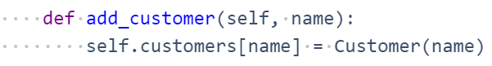

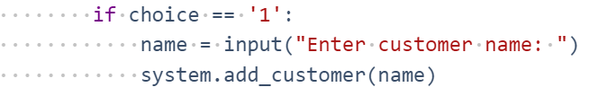

**Output:**

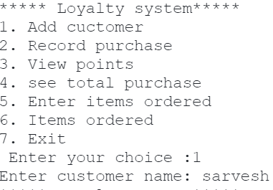

**7.1.2 record purchase**

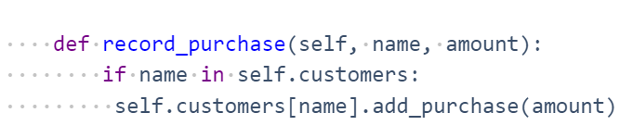

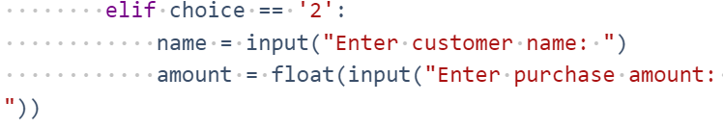

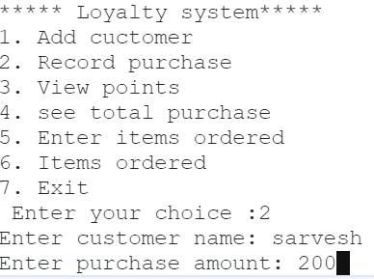

**7.1.3 display points**

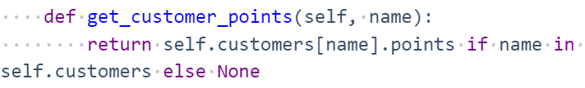

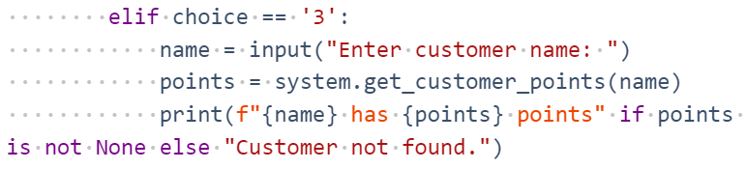

**Output:**

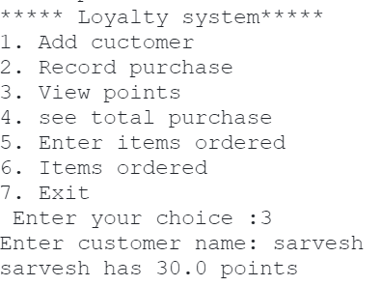

* 1. **Discussion**

A customer loyalty system tailored for the cuisine industry can significantly enhance customer retention, boost repeat business, and increase overall customer satisfaction. Here’s an in-depth discussion on key aspects, benefits, challenges, and strategies for implementing such a system. Offer rewards based on the number of visits or orders.

Provide points or discounts based on the amount spent. Special offers for birthdays, anniversaries, or festivals. Encourage customers to leave feedback and reviews in exchange for points or rewards. Implement elements like levels, badges, and leader boards to make the loyalty program more engaging.Provide early access to new dishes or exclusive events for loyal customers. Loyalty programs can be integrated into the restaurant’s mobile app. Seamless integration with Point of Sale systems to track customer spending and rewards. Leverage social media platforms to promote the loyalty program and engage with customers. Use data analytics to understand customer preferences and tailor offerings accordingly. Analyze purchase patterns to optimize menu offerings and promotions. Implement targeted marketing campaigns based on customer segmentation.A well-designed loyalty program encourages repeat visits, thereby increasing customer retention rates.Personalized rewards and offers improve the overall dining experience, making customers feel valued.Repeat customers tend to spend more, and loyalty programs can drive higher average order values.Satisfied loyal customers are more likely to recommend the restaurant to others, enhancing word-of-mouth marketing.Integrating a loyalty system with existing POS and online ordering systems can be technically challenging.Ensuring the security and privacy of customer data is crucial to maintaining trust.Continuously engaging customers and keeping the loyalty program interesting requires ongoing effort and creativity.Balancing the cost of rewards and discounts with the benefits gained from the loyalty program is essential.Define clear objectives for the loyalty program, such as increasing repeat visits, boosting average order value, or enhancing customer satisfaction.The program should be easy to understand and use. Complicated rules or difficult redemption processes can deter customers.Keep customers informed about their points, available rewards, and special promotions through regular communication channels like email, SMS, and push notifications.Regularly analyze the performance of the loyalty program and make necessary adjustments based on customer feedback and data insights.Ensure that staff are well-trained and understand the loyalty program thoroughly, so they can effectively promote it and assist customers.Starbucks’ loyalty program offers points (Stars) for every purchase, which can be redeemed for free drinks and food items. The program is integrated with their mobile app, making it easy for customers to track their rewards and receive personalized offers.

.

# Conclusion

**CHAPTER 8 CONCLUSION&FUTURESCOPE**

Implementing a customer loyalty system within the cuisine industry can profoundly impact customer satisfaction, retention, and overall business success. By focusing on personalized rewards, engaging user experiences, multi-channel integration, and data-driven insights, restaurants can build robust loyalty programs that resonate with their customers.

Tailoring rewards and offers based on individual customer preferences and behaviors enhances the dining experience and fosters a stronger connection with the brand.

#### Future Scope

The future of customer loyalty systems in the cuisine industry, especially when leveraged through Python programming, holds vast potential for innovation and enhanced customer engagement. Here are some key areas where advancements can be anticipated. Python's powerful libraries (e.g., scikit-learn, TensorFlow) can be utilized to predict customer behavior, such as predicting churn, identifying high-value customers, and forecasting demand. Machine learning algorithms can analyze past purchase data and preferences to provide personalized dish recommendations, enhancing the dining experience. Natural Language Processing (NLP) tools in Python can analyze customer reviews and feedback to gauge sentiment, helping restaurants to address issues proactively and improve service quality.

# APPENDIX

class Customer:

def items_ordered(self, item):

self.points += amount // 10

self.items +=','+item

class LoyaltySystem:

def __init__(self):

self.customers = {}

def add_customer(self, name):

self.customers[name] = Customer(name)

def record_purchase(self, name, amount):

if name in self.customers:

self.customers[name].add_purchase(amount)

def get_customer_points(self, name):

return self.customers[name].points if name in self.customers else None

def get_total_amount(self,name):

return self.customers[name].amount if name in self.customers else None

def item_purchased(self,name,item):

self.customers[name].items_ordered(item)

def purchased_items(self,name):

return self.customers[name].items if name in self.customers else None

def main():

system = LoyaltySystem()

while True:

print("***** Loyalty system*****")

print("1. Add cuctomer ")

print("2. Record purchase ")

print("3. View points ")

print("4. see total purchase ")

print("5. Enter items ordered ")

print("6. Items ordered ")

print("7. Exit ")

choice = input(" Enter your choice :")

if choice == '1':

name = input("Enter customer name: ")

system.add_customer(name)

elif choice == '2':

name = input("Enter customer name: ")

amount = float(input("Enter purchase amount: "))

system.record_purchase(name, amount)

elif choice == '3':

name = input("Enter customer name: ")

points = system.get_customer_points(name)

print(f"{name} has {points} points" if points is not None else "Customer not found.")

elif choice == '4':

name = input("Enter customer name:")

amount = system.get_total_amount(name)

print(f"{name} has purchased for ruppes = {amount}" if amount is not None else "customer not found.")

elif choice == '5':

name = input("Enter customer name:")

item = input("Enter the item ordered:")

system.item_purchased(name,item)

elif choice == '6':

name = input("Enter customer name:")

item = system.purchased_items(name)

print(f"{name} has ordered {item} before" if item is not None else"customer not found")

elif choice == '7':

break

if __name__ == "__main__":

main()